Building a Secure Multi-Tier Architecture

This project will build a secure multi-tier application, which will involve the following services:

- Amazon CloudFront
- Application Load Balancer
- AWS Certificate Manager
- Amazon SNS
- Amazon EC2
- Amazon KMS
- Amazon S3
- Amazon Inspector
- AWS Config
- AWS WAF

The diagram below depicts the overall architecture and the AWS services used:

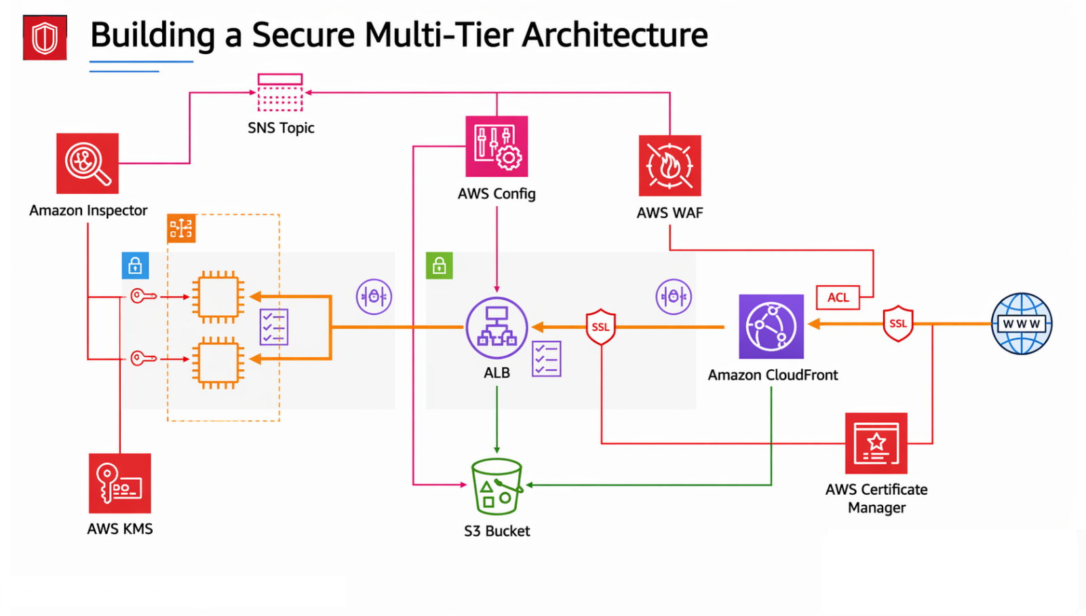

Requirements (Prerequisites)

● AWS Free Tier Account

Resources
See folder “building-a-secure-architecture-code” on GitHub repo
Exercise Overview
Exercise 1 – Create the Security Groups and Encryption Key
Exercise 2 – Create the TLS Certificate and SNS Topic
Exercise 3 – Create the Subnets, NAT Gateway & the Route table
Exercise 4 – Create the IAM Role, S3 Bucket, and Launch Template
Exercise 5 – Create the Auto Scaling Group and the Application Load Balancer
Exercise 6 – Create the CloudFront Distribution
Exercise 7 – Add the Route 53 records and Custom Headers
Exercise 8 – Enable logging for the ALB and CloudFront
Exercise 9 – Enable AWS Config and AWS WAF
Exercise 1 – Create the Security Groups and Encryption Key

Task 1 – Create the EC2 Security Groups

First we will create the Security Groups for the EC2 instances which will form the compute layer.
- Head over to the EC2 management console and click on Security Groups on the left-hand side of the page.
- Click ‘Create Security Group’, name it ‘ALBFrontEnd’, add a description, and leave the default VPC selected.

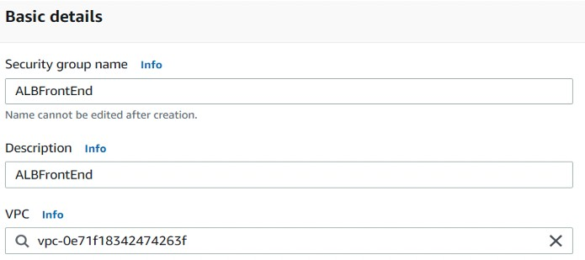

- Add an inbound rule allowing the HTTPS protocol from anywhere and click ‘Create Security Group’.
- Create a second security group named ‘EC2Backend’ and add a rule allowing HTTP from the ‘ALBFrontEnd’ security group. This ensures that only traffic from the load balancer can access the EC2 instances. Click ‘Create’.

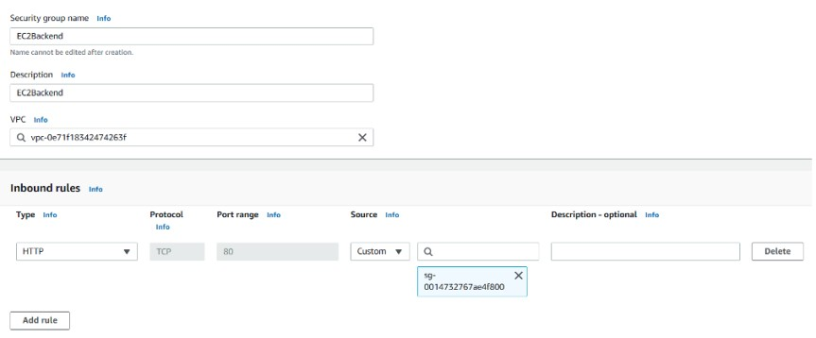

- Go back into the ‘ALBFrontEnd’ security group and delete the existing outbound rule and create a new rule that allows HTTP to the ‘EC2Backend’ Security Group.
- Click ‘Save Rules’.

Task 2 – Create the Encryption Key using KMS

Next, we will create the encryption key using KMS.
- We are going to go the Key Management Service in the console and click ‘Create a key’.
- Keep the key as Symmetric and click next.
- Call the key ‘MyDataKey’ and click on next.
- Tick your current user in the ‘Key Administrators’ box:

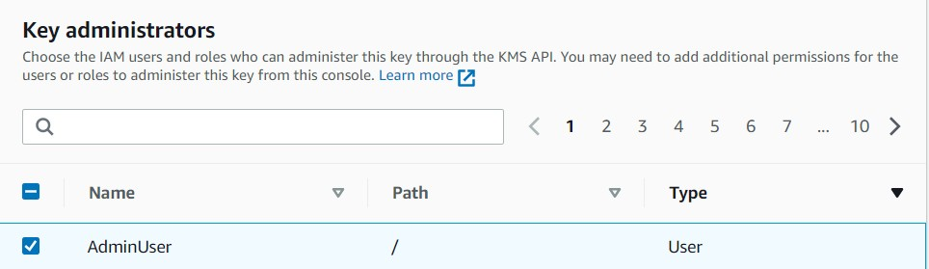
- Click next, and under ‘Define Key usage permissions’ select the same user and select ‘AWSServiceRoleForAutoScaling’. Click next.
- Click ‘Finish’ to create the key.

Exercise 2 – Create the TLS Certificate SNS Topic

Task 1 – Create the Certificate using Amazon Certificate Manager

Next, we will create the Certificate for the Load Balancer using ACM.
- Go to the ACM console and click ‘Request a Certificate’. You should have created a domain name earlier in the course, so we will be reusing it now.
- Request a public certificate and enter the fully qualified domain name for your registered public domain (for example ‘dctcloudlabs.com’).
- Add ‘alb.<your domain name>’ as a second domain name.
- Select ‘DNS Validation’ and click request.
- After a brief delay while ACM populates your domain validation information, click on the Certificate and click ‘Create records in Route 53’ to allow the CNAME records to be created for each domain.

Task 2 – Create the SNS Topic

Next, we will create the SNS Topic for later.
- Go to the SNS console and click ‘Create Topic’. Select a standard topic.
- Call it ‘MyNotification’ and click ‘Create Topic’.
- Click ‘create subscription’ select ‘email’ as the protocol and enter your email address.

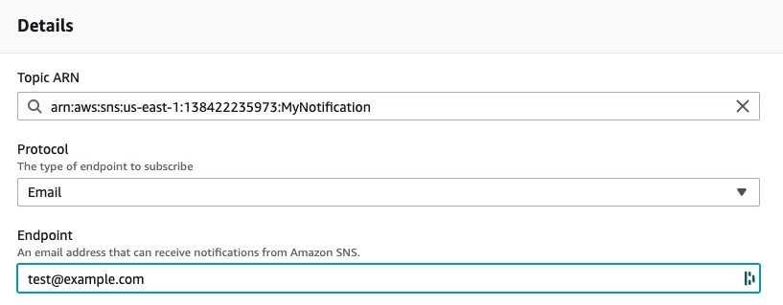

- Click ‘Create subscription and go to your inbox and confirm the subscription.

Exercise 3 – Create the Subnets, NAT Gateway & the Route table

Task 1 – Create the Subnets, NAT Gateway & the Route table

Use the commands in the aws-cli-commands.md file to create the subnets, route table, and NAT gateway.

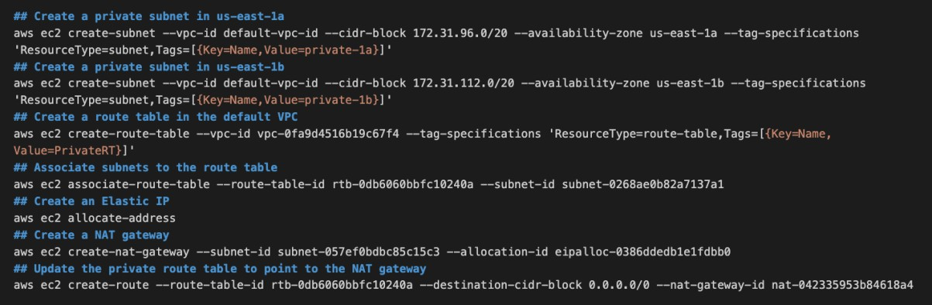

Exercise 4 – Create the IAM Role, S3 Bucket, and the Launch Template

Task 1 – Create the IAM Role

Next, we will create the IAM role for the EC2 instances to access static contents from S3.
- Go to the IAM console and click on ‘Roles’ and ‘Create Role’.
- Under use case, select ‘EC2’ and click next.
- Search for ‘AmazonS3ReadOnlyAccess’ and select tis managed policy.
- Do the same with ‘AmazonSSMManagedInstanceCore’,then click next.
- Call your role ‘ec2-ssm-s3’ and click ‘Create Role’.

Task 2 – Create the S3 Bucket and the Launch Template

Next, we will create the S3 Bucket to store our static assets.
- Go to the S3 console and click ‘Create Bucket’.
- Call your bucket an iteration of ‘dct-labs-123456’ – edit the numbers as all bucket names must be globally unique.
- Click ‘Create Bucket’.
- Upload the ‘index.txt’ file from the resources download.
- Head over to the EC2 console and go to ‘Launch Templates’ and click ‘Create Launch Template’. Call it ‘MyLT’.
- Use the Amazon Linux 2023 AMI as the AMI image and choose the t2.micro instance type.
- Choose the ‘EC2Backend’ security group we created earlier.
- Under ‘EBS volumes’, encrypt your volume and select the KMS Key we created earlier.

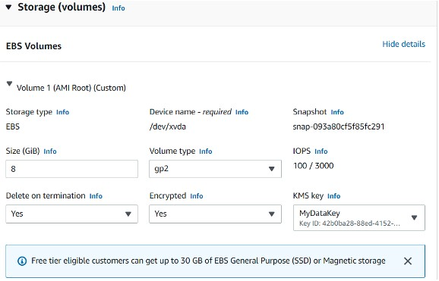

- Choose the ‘ec2-s3-ssm’ instance profile we created earlier under ‘instance profile’.
- Open the ‘user-data-httpd.md’ file, edit the bucket name, and then paste the code in the ‘User data’ section.

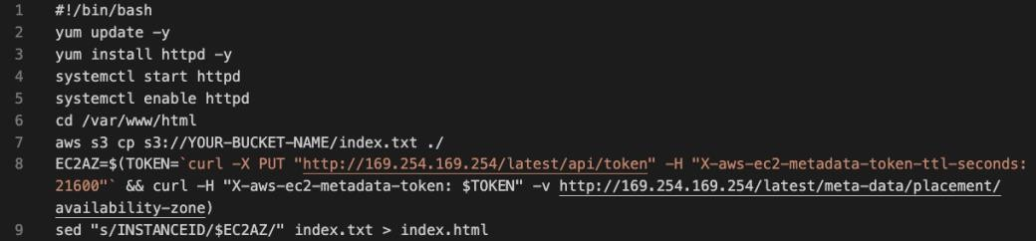

- Update YOUR-BUCKET-NAME and then click ‘Create launch template’.

Exercise 5 – Create the Auto Scaling Group and the Application Load Balancer

Task 1 – Create an Amazon EC2 Auto Scaling Group

We will create an Amazon EC2 Auto Scaling group.
- Head over to the EC2 management console and click auto scaling groups.
- Call your ASG ‘ASG1’ and select the ‘MyLT’ Launch template from earlier – and click next.
- Choose the two private subnets within the default VPC – private1a and private 2a and again click next, then next again.
- Enter ‘2’ for each capacity value.
- Click next, until you get the review page and then click ‘Create Auto Scaling Group’.

Task 2– Create an Application Load Balancer

We will create the Application Load balancer and attach it to the Auto Scaling Group.
- Right-click on ‘Load Balancers’ and open in a new tab. Click ‘Create Load Balancer’ – Select ‘create’ under the Application Load Balancer.
- Call the ALB ‘ALB’ and select the public subnets within the Availability Zones us-east-1a and us-east-1b under mappings, not the private ones! also choose the ALBFrontEnd security group and remove the default route.

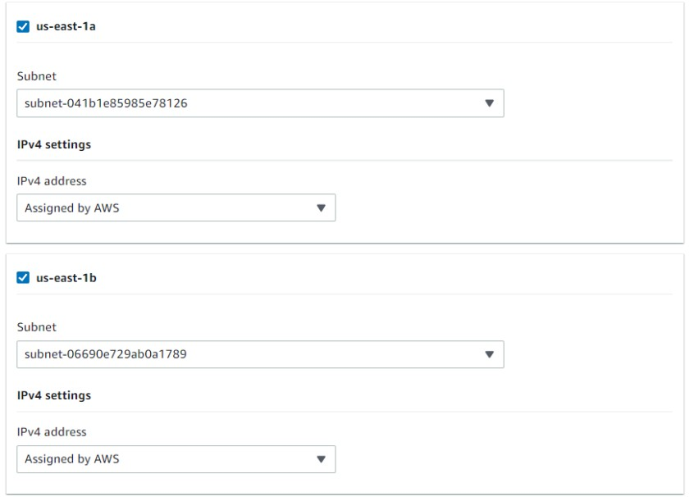

- Choose port HTTPS for the listener protocol and port and add the certificate created earlier.
- Return to the previous browser tab and check the status of the Autoscaling Group instances. Once they are in service, return to the load balancer tab and click ‘Create Target Group’. This will open in a new browser tab.
- Call your Target Group ‘TG1’ and select HTTP and port 80.

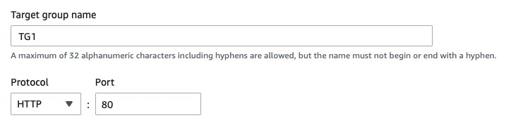
- Select both instances and select ‘Include as pending below’ and click create target group.
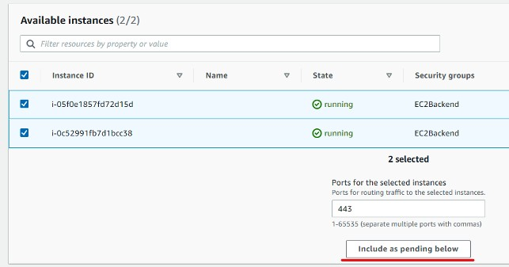
- If we go back to the ALB creation page and refresh the options for the target group, we should be able to select TG1.
- Click ‘Create Load Balancer.’
Exercise 6 – Create the CloudFront Distribution

Task 1– Create the CloudFront Distribution

Now we will create the CloudFront distribution to go in front of the load balancer before we add the Route 53 records.

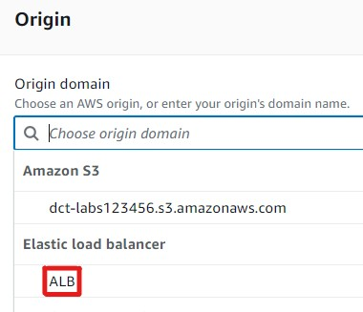
- Head over to the CloudFront console and click ‘Create a CloudFront Distribution’.
- Under ‘Origin Domain’ find the ALB which we just created. This will change some settings.
- Change the origin domain name to your subdomain name, e.g. ‘alb.dctcloudlabs.com’.
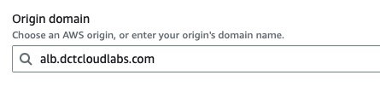

- Under ‘Origin’ change the protocol to ‘HTTPS only’.

- Under Viewer change the viewer protocol policy to ‘Redirect HTTP to HTTPS’.
- Under Cache Policy choose “CachingDisabled”.
- Under WAF choose "Do not enable security..."
- Under ‘alternate domain names’ add the name of your domain without the ‘alb’ in front of it, (e.g. ‘dctcloudlabs.com’.)
- Select the custom SSL certificate for the root domain under ‘Custom SSL certificate’.
- Finally add ‘index.html’ under the default root object and click ‘Create distribution.

Exercise 7 - Add the Route 53 records and Custom Headers

Task 1– Add the Route 53 records and Custom Headers

- Head over to the Route 53 console and click on your custom domain name under hosted zones.
- Click on Create Record and use the quick create view.
- Enable the ‘Alias’ switch box and select the CloudFront distribution in the us-east-1 Region.
- Create another record as an alias to your Application Load Balancer using the subdomain, e.g. alb.dctcloudlabs.com.

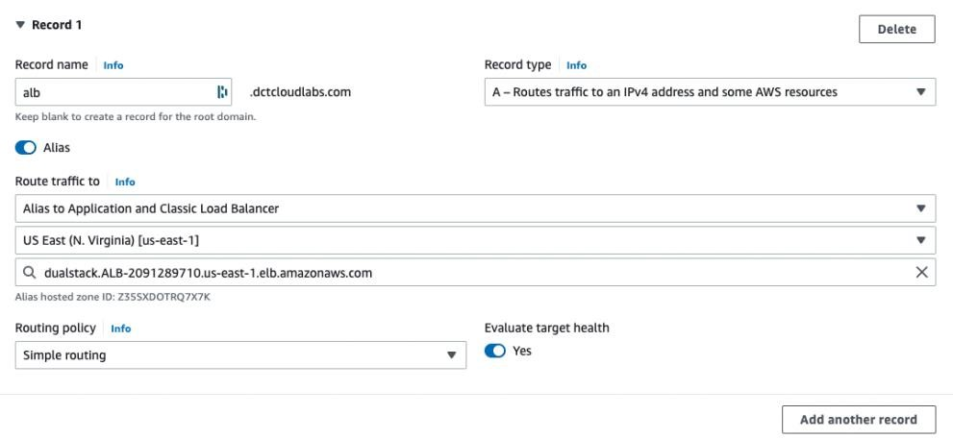

- You should be able to connect to your ALB directly using the HTTPS protocol and the custom subdomain name, e.g. https://alb.dctcloudlabs.com.
- If you refresh you should see that the AZ is changing due to load balancing.
- If you then connect to the main domain, e.g. https://dctcloudlabs.com you should be able to access the website via the CloudFront distribution.

Task 2– Add Custom Headers

- We now need to add a custom header to prevent users from circumventing the CloudFront distribution and connecting via the Load Balancer.
- Go the CloudFront console and click on the distribution we just created. Under origins, select the origin and click Edit.
- Add the following value for the header name, and for the value add ‘value-XXXXXX’ with the Xs representing random numbers. Then copy this value, we will be using it shortly.

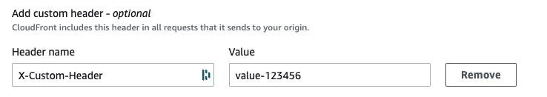

- Click save changes and head over to the Load Balancer, go to Listeners. Select the listener, and from ‘Actions’ click ‘Manage rules’.
- Add the following rule with the plus icon in the top left corner:
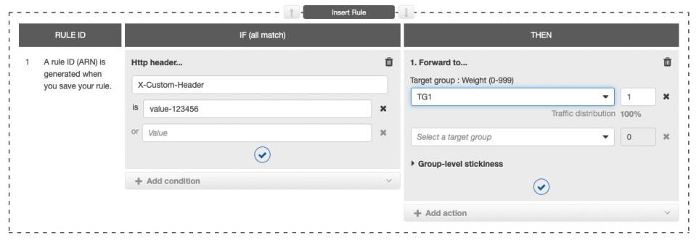

- Then, modify the last rule; remove the forwarding to TG1 and select to ‘Return a fixed response’. Enter ‘Access denied!’ in the response body.

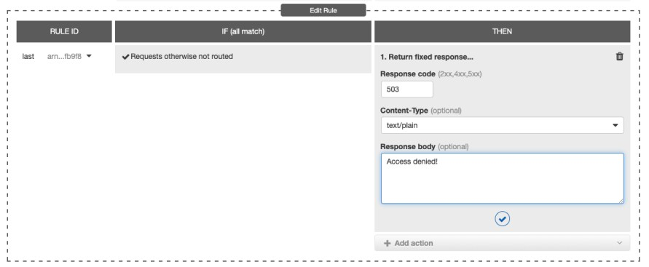

- If we then try to connect via the Load balancer directly (https://alb.dctcloudlabs.com) you will see the following message!
Access Denied!
- You should still be able to access the website via the CloudFront distribution using the root domain name, e.g. https://dctcloudlabs.com.

Exercise 8 – Enable logging for the ALB and CloudFront

Task 1 – Enable logging for the ALB and CloudFront

Here we are creating an S3 bucket and enabling logs on the ALB and the CloudFront distribution.
- Go to S3 and create a bucket named ‘my-logging-bucket-xxxxxx’ changing the Xs to a random string of numbers and letters.
- Add a bucket policy using the code in the alb-access-logging-policy.json file. You need to add your account number where it says ‘YOUR-ACCOUNT-ID’. Do NOT edit the account number in the Principal section.
- Go to your load balancer. On the ‘Actions’ menu, click ‘Edit load balancer attributes’.
- Flick the switch for ‘Access logs’ and then enter the URI of the bucket (or use the browse function).
- Go back to S3 and inspect the bucket that was created. You should soon see logs starting to populate and we can see that the permissions policy was created for us to allow this to happen.
- We will now turn on logging for CloudFront. Go to your distribution and click ‘General’ and click ‘Edit’ in the ‘Settings’ section. Select the box for ‘Standard Logging’.
- Enter the bucket which we created for logging purposes and enter the prefix ‘cloudfront’.
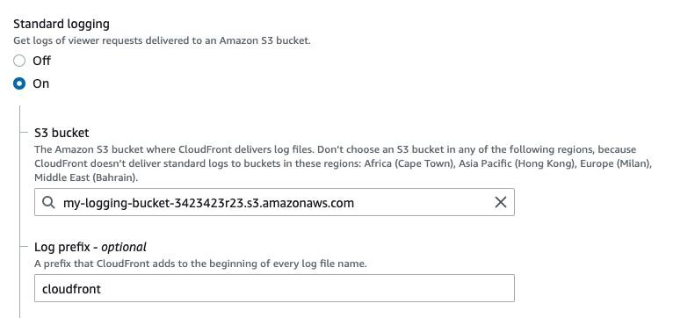
- Click ‘Enable ACLs’ if prompted to do so. Click ‘Save’.

Exercise 9 – Enable AWS Config and AWS WAF

Task 1 – Enable AWS Config

Here we are enabling AWS Config to ensure the configurations do not drift from expected configuration.
- We will set up the automation rule which will require a role that can be assumed by AWS Systems Manager. The role should have the ‘AmazonS3FullAccess’ permissions policy attached.
- We need to go to the AWS IAM console and create a role with the AWS Managed policy
‘AmazonS3FullAccess’.
- In the navigation pane, choose "Roles", then "Create role".
- On the "Select type of trusted entity" page, choose "AWS service" as the trusted entity, and select "Systems Manager" from the list of services.
- On the "Attach permissions policies" page, search for and select the "AmazonS3FullAccess" managed policy.
- Call it ‘AutomationAssumeRole’, review the role, and then click "Create role" to create the role. Save the ARN for this role.
- Head over to the AWS Config console and click ‘Get started’.
- We need to setup AWS Config First in the config console first.
- On the left-hand site of the console, under ‘Settings’, click ‘Edit’ (you may find these settings in the setup wizard) and for ‘Delivery method’ select the SNS Topic we created earlier.

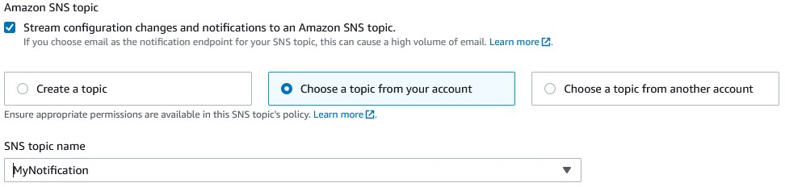

- For ‘Amazon S3 bucket’ select ‘Create a bucket’ and accept the default name. Save the configuration settings.
- Now we will click on rules and add a rule.
- Choose ‘s3-bucket-versioning-enabled’ and click next, next again then add the rule.
- Add another rule called ‘elb-logging-enabled’ and click next, next again then add the rule.
- We should then see the rules, and we should soon see that we have some non-compliant resources.
- For the S3 versioning rule click ‘Actions’ and ‘manage remediation’.
- Choose automatic remediation and choose the ‘AWS-ConfigureS3BucketVersioning’ remediation action.
- Choose “BucketName’ for the resource ID parameter and enter the ARN of the role you created under ‘Parameters > AutomationAssumeRole’. For ‘VersioningState’, enter ‘Enabled’. You can then save changes and run a test on a specific bucket.

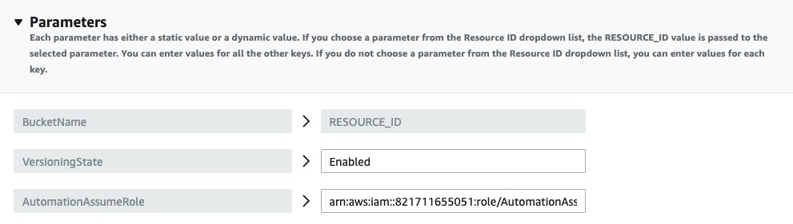

Task 2 – Check the instances are present in Systems Manager and Amazon Inspector

Head over to the AWS Systems Manager console, and click on ‘Fleet Manager’ to confirm the instances are there:

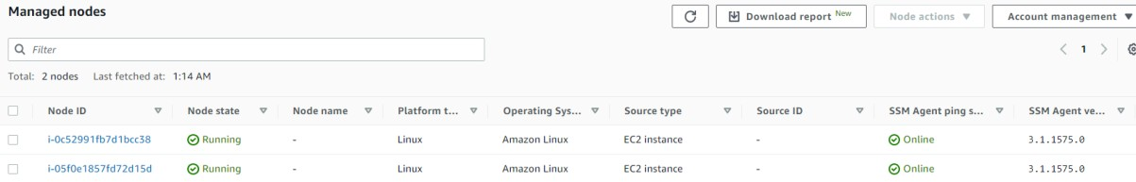

- Go to ‘Run command’ and click ‘Run a command’.

- Search for ‘inspector’ in the search box and choose the following option:

AmazonInspector-ManageAWSAgent

- Scroll down and select both instances manually, deselect writing the output, and click ‘Run’.
- You can then click the instance-id to view the results of the command.
- Head to Amazon Inspector and view the results through inspector.

Task 2 – Enable AWS WAF

Here we are enabling AWS WAF.
- Go over to the AWS WAF console and click ‘Create web ACL’.
- Under resource type, change to ‘CloudFront distributions’ and call it ‘MyWebACL’.
- Select ‘Add AWS resources’ and add the CloudFront distribution:

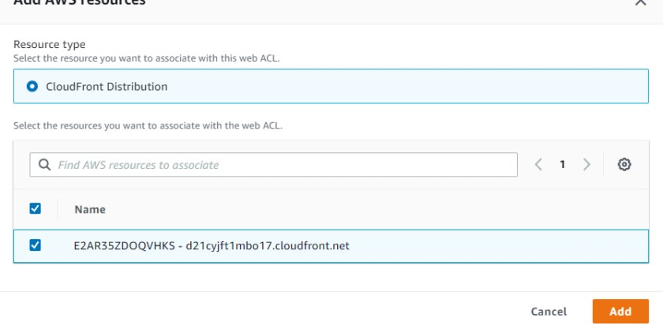
- Under rules click ‘Add my own rules and rule groups’ and call the first rule ‘Rate100’ and under ‘Type’ choose a rate-based rule.
- Choose 100 for the rate limit and add the rule. Complete the creation of the Web ACL.
- If you then try to access the CloudFront distribution and refresh your browser more than 100 times on the webpage, you will get an error message and it will stop working. Use the command in the aws-cli-commands.md file to run the refresh automatically using CloudShell.
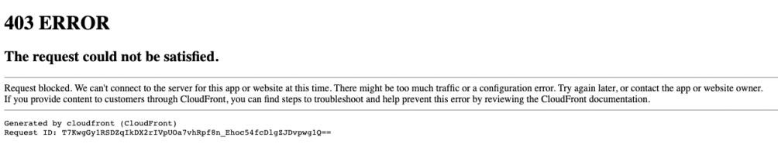
- Lastly, go back and check the Amazon Inspector console and AWS Config to see the security findings.

Don’t forget to terminate/delete the following resources:
- Application Load Balancer
- Auto Scaling group
- NAT Gateway
- CloudFront Distribution
- WAF Rule
- KMS encryption key
- S3 Bucket

